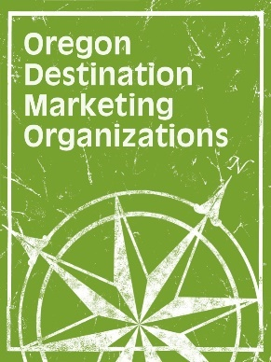

OREGON DESTINATION
MARKETING ORGANIZATIONS

Membership Meeting Agenda

3:00 p.m., December 4, 2016

Embassy Suites, Washington Square

Call to Order & Introductions

Action Items:
Minutes from April Membership Meeting

Reports:

Financial Report

2017 Governor’s Tourism Conference Auction

Industry Updates

Legislative Report

New Business

State-wide Guest Service Training Program – Wendy Popkin &

Cariole Astley

Good of the Order

VI. Adjournment

