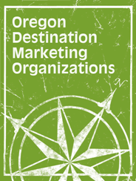

**2016 ANNUAL CONFERENCE**

## December 4-6, 2016

###### Embassy Suites, Washington Square

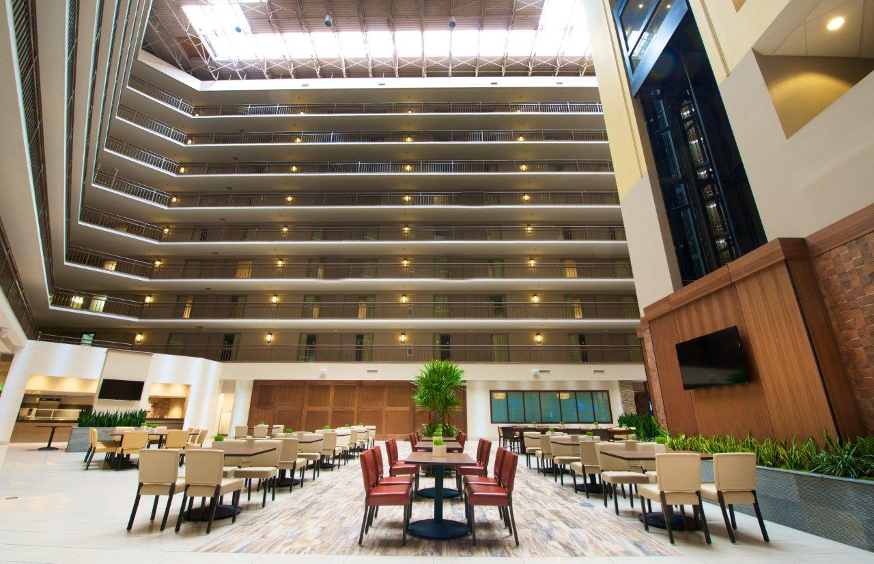

### WELCOME

On behalf of ODMO’s Board of Directors and Executive Director Bill Cross, it is my pleasure to welcome you to the 2016 Winter Conference. The Board of Directors has lined up a great program for the Winter Conference.

**Special thanks to our sponsors whose financial support helps defray some of the costs associated with this conference. 2016 Winter Conference Sponsors include:**

#### Presenting Sponsor ($2,000)

***Oregon Restaurant & Lodging Association***

Presidential Sponsor ($1,000)

***Mt. Hood Territory***

***Washington County Visitors Association***

Platinum Sponsor ($750)

AAA VIA Magazine/Western Journey

***Explorer Media, NW Travel & Life Magazine, and Meeting News NW***

Gold Sponsor ($600)

***MEDIAmerica***

***SagaCity Media***

***CrowdRiff***

Silver Sponsor ($450)

#### Oregon Media

#### Oregon Travel Experience

dd01434_ODMO is very grateful to the speakers for the time and knowledge they contribute to the Winter Conference program.

Best wishes,

Angie Morris

President

ODMO ANNUAL CONFERENCE

December 4-6, 2016, Embassy Suites, Washington Square

**Sunday, December 4, 2016**

3:00 – 3:30 p.m. – *Membership Meeting*

3:30 - 3:45 p.m. – *Member Services / New Members Service Possibilities / Annual Report* – Angie Morris, ODMO President and President & CEO, Travel Salem & Cultivating Communities

3:45 – 4:30 p.m. – *Marketing Trends and Best Practices* – Valerie

Warren, ODMO Past President and VP, Operations & Policy, Visit Bend

* Jim Chadderdon, Discover Klamath – speaking on the recent development, launch, and multi-year plan for their “Meet Me in Klamath” rebranding campaign
* Natalie Inouye, Travel Lane County – speaking on their Pinot Bingo campaign
* Jarrod Lyman, Mt. Hood Territory – speaking on using/best practices of Facebook Live video

4:30 – 5:00 p.m. – *What Does the Bump in Oregon’s Bed Tax Mean?*  – Alice Trindle, ODMO Treasurer and Executive Director, Eastern Oregon Visitors Association

* Regional – RCTP & Regional Investment
* Statewide – TO Grants, Budget & Programs
* Future Legislation – Local Government Interest in the Local TRT Funds

5:00 – 5:15 p.m. – *Vacation Rentals (airbnb)*

5:15 – 6:00 p.m. – *Roundtable Table Conversations*

* How Can We Use the Dean Runyan Report to Help Leverage Conversations
* Emergency Preparedness
* The Eclipse

6:30 p.m. – *Holiday Reception & Dinner* – Mingo Restaurant, Beaverton

**Monday, December 5, 2016**

7:30 – 8:30 a.m. – *Breakfast and Networking*

8:30 – 10:30 a.m. – *Travel Oregon Presentation*

* RCTP/Grants Program Updates – Jeff Hampton, VP of Operations
* Eclipse Planning – Linea Gagliano, Director of Communications
* Marketing Campaign Update (Winter + Spring 2017) – Katy Clair, Marketing Manager
* TravelOregon.com Update – Mo Sherifdeen, Director of Integrated Content
* Destination Development update (includes info on Tourism Studios and product development) – Kristin Dahl, VP of Destination Development
* Brand USA Content Project 2017 – Teresa O’Neill, VP of Global Sales

·

10:30 – 10:45 a.m. – *Refreshment Break*

10:45 a.m. – 11:30 – *Getting Ready for* *TrackTown* – Kari Westlund, President & CEO, Travel Lane County

* With close to 200 countries participating in the 2021 International Track & Field Championships, many teams will be shopping for training sites in advance of the event - two to four week stays to acclimate and train together. What kind of in information and facilities will they be looking for and how to assemble that information.
* Preparing materials for use in the international broadcast, which TrackTown will control and goes to more countries than the Super Bowl, and what we should be doing between now and the event to leverage it fully.

11:30 – Noon. – *Wayfinding 101 – Blue, Brown, Green and White Signs –* Nancy DeSouza, Executive Director, Oregon Travel Experience.

* How to work with OTE restrictions to get blue, brown, green and white signs. What do the heritage signs do for your community? Who to work with to get wine/beer trail signs and creating districts to add more signage? The Applegate Trail…a case study.

12:00 -1;15 p.m. – Lunch & Keynote Presentation

*Global Awareness & Cultural Expectations –* Valerie Berset-Price, Founder & Managing Director, Professional Passport

* Understanding how to position oneself mindfully amid cultures is one of the most crucial skills one can incorporate in a world that is now fully interconnected and in which international business is synonymous with local growth. Valérie Berset-Price’s Professional Passport’s Global Awareness Training program focuses on optimizing collaboration across cultures by teaching how to build trust and respect with people who do not share one’s cultural DNA.

1:15 – 2:30 p.m. – *Tourism Just Got (More) Interesting* –Niki Terzieff, ODMO Government Affairs Advocate and President, Leading Edge Public Affairs; Jeff Rhoades, Senior Policy Advisor on Cannabis to Governor Kate Brown; Don Morse, Chairman, Oregon Cannabis Business Council; and, Sam Chapman, CEO, New Economy Consulting

* Legal, recreational, cannabis use is right around the corner and Oregon has an opportunity to plant a seed for unique growth in tourism.  Be enlightened on the many and varied regulations governing this budding industry that stem from a handful of agencies, a legislative body, one governor’s office and a myriad of local governments.  Without getting too far into the weeds, this presentation will concentrate the most important information for your DMO.

2:30 – 3:15 p.m. – *Around the Region and Refreshments*

3:30 – 6:15 p.m. – *Evergreen Curling Club & the NIKE Employee Store*

* Take to the ice and experience the sport of curling at the Evergreen Curling Club, the Northwest’s leading championship curling facility. Start with an off-ice introduction, then let the games begin with on-ice instruction and participation. No experience is necessary, and all skills and abilities are welcome to participate in this accessible and fun sport. With the coveted “Golden Ticket” in hand, access the NIKE Employee Store for 50%-off the latest Nike apparel and shoes for men, women and kids. Peruse the racks and rake-in the savings!  *To earn a Golden Ticket, names must be submitted to ODMO* ***prior to the event****; current and valid picture ID is required to enter the Employee Store. No exceptions.*

6:30 – *ODMO, OTC & TO Reception & Dinner* *– Embassy Suites, Washington Square*

**Tuesday, December 6, 2016**

9:00 a.m. – Noon – *OTC Meeting* – Embassy Suites, Washington Square